**1st  Reader Response**

**- Introduction to Research**

Defined Research by The ‘noion’:

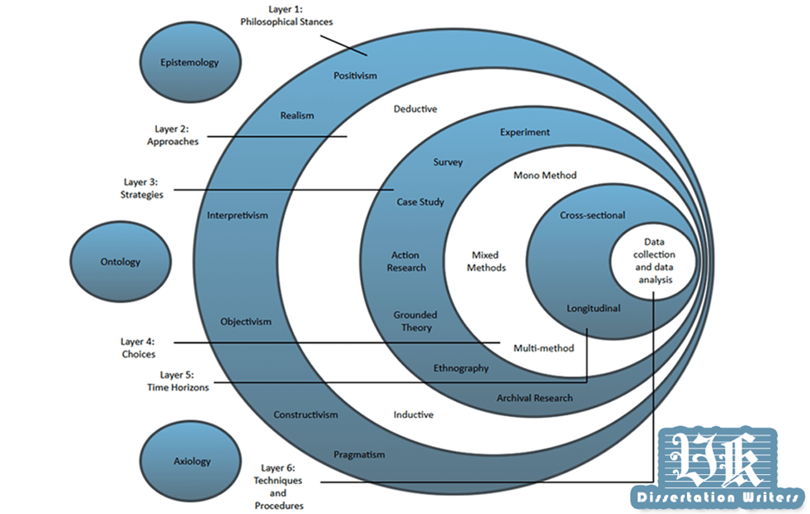

Include:

1、Date collection and date analysis；

2、Cross-sectional and Longitudinal；

3、Experiment, Survey, Case study, Action Research, Grounded Theory, Ethnography, Archival Research ；

4、Deductive, Inductive；

5、Positivism, Realism, Interpretivism. Objectivism, Constructivism, Pragmatism。

6、 Epistemology, Ontology, Axiology

Research Process :

Include:

1. Identify and formulate the research topic or problem
2. Literature search and review
3. Research objectives, questions, and hypotheses
4. Research approach, design, and strategy
5. Data collection
6. Data analysis
7. Generalisation
8. write-up

research scientific:

Include:

1. scientific method
2. is based upon empirical observation
3. are gathered, evaluated, and used to produce new knowledge are termed methodology

Evaluate of scientific research:

Include:

1. Reliability
2. Replication
3. Validity

Research ideas come from:

1. Personal or professional experience
2. Theory
3. Literature and the media

Formulating the research problem(“SMART”):

1. Literature and the media
2. S Specific
3. M Mesasurable
4. A Attainable
5. R Relevant
6. T Time-Based

Types of Research:

**1.Experimental Research**

The dependent variable depends on the independent variable.

Independent Variable(IV) affects Dependent Variable(DV)

1. Correlational **Research**:Examines the relationship among two or more variables; looks for a cause and effect

**3.Causal-comparative Research** :Determine the cause for, or consequences of, differences between groups of people

**4.Survey Research** :Obtains data to determine specific characteristics of a group

**5.Ethnographic Research** :Emphasize documenting or portraying the everyday experiences of the individuals by observing and interviewing them in naturalistic setting

**6.Historical Research :**The major problem of this research is the question of using an event or time sequence as a true outcome

**7Action Research** :research toward the enhancement of direct practice